Fire and Gas FYP Overview

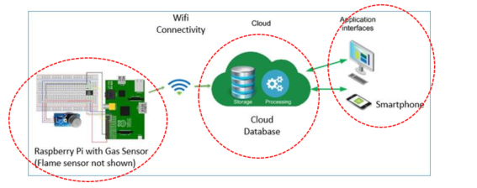

(Thinger Cloud, Ubidots Cloud, ThingSpeak Cloud, GroveStreams Cloud)?

API Documentation?

Programming lang (needed?)

Sample Codes on Internet (Put Data, Retrieve Data)?

**Bentley**

6P: Basic Code for Web Application: Login, logout?

Programming lang? Java, .NET

API: Plot Chart, Plot Table?

**Bryant**

Raspberry Pi OS?

Programming lang? Java

Sample Codes on Internet (Read Sensor Data, Send Sensor Data)?

**Joseph**

Raspberry Pi Programming:

??

Ubidots Programming:

<https://ubidots.com/docs/hw/#introduction>

Web Application Programming Using .Net:

<https://dotnet.microsoft.com/learn>